Kilcormac (KRMA)
Tuesday 3 March 2026
10:32

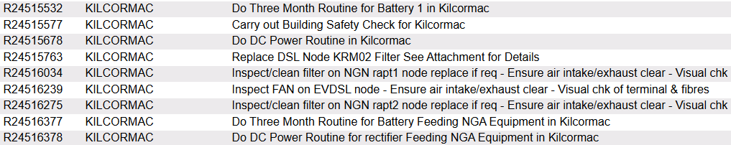

+ Please clean/replace filter on KRMA-MSAN
+ Inspect FAN on FTTH node KRM1-F01A - Ensure air intake/exhaust clear

Do Three Month Routine for Battery 1 in Kilcormac

The overall: 53.99
Cell # | Voltage (V) | Cell # | Voltage (V)
1 | 2.26 | 13 | 2.26
2 | 2.24 | 14 | 2.25
3 | 2.24 | 15 | 2.25
4 | 2.26 | 16 | 2.26
5 | 2.25 | 17 | 2.25
6 | 2.22 | 18 | 2.25
7 | 2.23 | 19 | 2.25
8 | 2.25 | 20 | 2.28
9 | 2.25 | 21 | 2.27
10 | 2.25 | 22 | 2.26
11 | 2.23 | 23 | 2.26
12 | 2.25 | 24 | 2.25

From <https://gemini.google.com/app/d6fda23163c68003>

Do DC Power Routine in Kilcormac (Powec)

Rectifiers | 5
DC Power Load | 19.1
Boost Voltage | 54
Float Voltage | 54.0

Alarm Limits
Low Voltage | 47
High Voltage | 58
High Load | 100%
High Temperature | 30 °C - not wired

Low Voltage, High Voltage and High Load, alarms were tested, 2 alarm were visible.

2A Do Three Month Routine for Battery Feeding NGA Equipment in Kilcormac

Temperature: 17 C
Overall voltage: 54.57
13.64 | 13.61 | 13.62 | 13.59

Do Three Month Routine for Battery Feeding NGA Equipment in Kilcormac (Power One)
Rectifiers | 5
DC Power Load | 14
Boost Voltage | 54.1
Float Voltage | 54.1

Alarm Limits
Low Voltage | 47
High Voltage | 58
High Load | 80%
High Temperature | 30 °C

Low Voltage, High Voltage, High Load, and High Temperature alarms were tested, but only one Low voltage

